|  |  |  |  |  |
| --- | --- | --- | --- | --- |
|  | **ATPHY 2018**   |  |  | | --- | --- | | **Electromagnetism Investigation** | **3.0%** |   **Part (2) Quiz: _____/ 50** | |
| Student name: | |  |

**You should have your Research section of the investigation with you.**

1. State what the betatron is mainly used for. [3]

|  |
| --- |
|  |
|  |
|  |

2. What is the value of the speed mentioned as *v* = 0.999987*c* where *c* is the speed of light? Give your answer to 5 significant figures. [2]

3. Show that 1 Volt = 1 Weber / second. [3]

4. Explain why an electron-volt can be considered to be a unit of energy. [2]

5. Can an induced current ever establish a magnetic field B that is in the same direction as the magnetic field inducing the current? Justify your answer. [3]

|  |
| --- |
|  |
|  |
|  |

|  |
| --- |
|  |

6. Suggest a suitable material for the magnetic core of the betatron. Justify your answer. [2]

|  |
| --- |
|  |
|  |
|  |

7. In the betatron, the magnetic core is made of laminated sheets rather than of solid material. Explain why this is so. [3]

|  |
| --- |
|  |
|  |
|  |

|  |
| --- |
|  |

8a) Explain how the magnetic field guides the electrons in a circular path. [2]

|  |
| --- |
|  |
|  |
|  |

b) Explain how the changing magnetic field produces an induced electric field in the electron chamber. [2]

|  |
| --- |
|  |
|  |
|  |

9. You want to increase the radius of the circular path by imposing an additional magnetic flux $∆Φ$. Should the lines of *B* associated with this increase be in the same direction as the lines shown in the figure or in the opposite direction? Explain your answer. [3]

|  |
| --- |
|  |
|  |
|  |

|  |
| --- |
|  |

10. State the direction of the force acting on the electron on the right hand side of the betatron (Fig. 1 of Research handout) [1]

_________________________________________________________________

Explain how you arrived at your answer. [2]

|  |
| --- |
|  |
|  |
|  |

**11.** In a 100-MeV betatron, the orbit radius *R* is 84 cm. Assume that the orbit is circular. The magnetic field in the region enclosed by the orbit rises periodically (60 times per second) from zero to a maximum value $B_{max}=0.8\text{T}$ in an accelerating interval of one-fourth of a period, or 4.2 ms.

(a) What is the maximum magnetic flux, $Φ_{max}$, attained during the accelerating interval? [2]

(b) Using the answer to (a), determine the rate of change of flux (induced emf) during the time interval of acceleration. [2]

(c) Given that 1 eV (electron volt) is the energy gained by an electron moving across a potential difference of 1V, show that the number of revolutions required for an electron to reach its final energy of 100 MeV is approximately 238,000 revolutions. [2]

(d) Find the total distance travelled by an electron along its circular path before reaching its full energy of 100 MeV. [2]

(e) Calculate the average speed of the electron as it travels the total distance needed to reach 100 MeV during the acceleration time interval of 4.2 ms. [2]

12. The varying magnetic field in the betatron can be represented by the graph below:

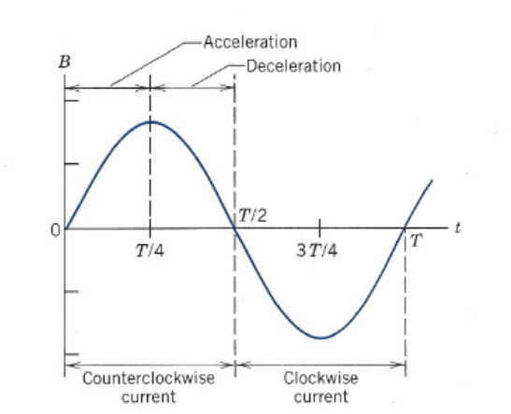

On the axis below, sketch the shape of a corresponding graph of induced emf versus time as the B field varies. [3]



13. Once accelerated, the electrons are directed out of the doughnut chamber, or inwards, towards a metal target to produce x-rays.

X-rays are a form of electromagnetic radiation. They have a wavelength ranging from 0.01 to 10 nm.

What are the highest and lowest frequencies of x-rays? [3]

14. The betatron can be thought of as a transformer. Transformers have a primary and secondary coil. The magnetic field is changed by passing alternating current to the primary coil. A current is induced in the secondary coil by Faraday’s Law. [2]

(a) State which part of the betatron behaves like the primary coil of a transformer.

|  |
| --- |
|  |

(b) State which part of the betatron behaves like the secondary coil of a transformer.

|  |
| --- |
|  |

15. Referring to the values given in Question 11, suggest some strengths of the design of a betatron as a particle accelerator. [2]

|  |
| --- |
|  |
|  |
|  |

16. What are some ways that you can increase the energy of radiation emitted by the betatron? [2]

|  |
| --- |
|  |
|  |
|  |

**END OF QUIZ**